Advanced SQL
Exercise 1: Ranking and Window Functions
create database productdb;
use productdb;
create table products(
productid int primary key,
productname varchar(50),
category varchar(50),
price decimal(10,2)
);
insert into products values
(1,'Laptop A','Electronics',800),
(2,'Laptop B','Electronics',1200),
(3,'Laptop C','Electronics',1200),
(4,'Phone A','Electronics',600),
(5,'TV A','Electronics',1500),
(6,'Chair A','Furniture',200),
(7,'Chair B','Furniture',300),
(8,'Table A','Furniture',500),
(9,'Table B','Furniture',500),
(10,'Sofa A','Furniture',1000),
(11,'Shirt A','Clothing',50),
(12,'Shirt B','Clothing',80),
(13,'Jeans A','Clothing',100),
(14,'Jacket A','Clothing',150),
(15,'Jacket B','Clothing',150);
select * from products;

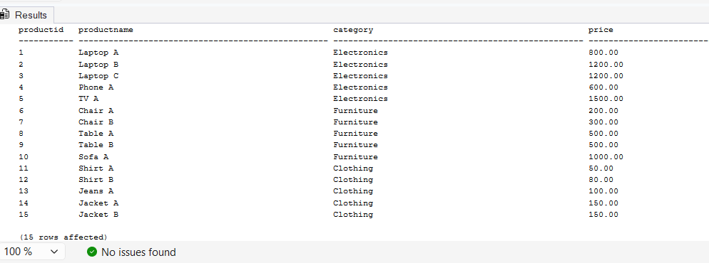
select
productid,
productname,
category,
price,
row_number() over
(
partition by category
order by price desc
)
as rownum
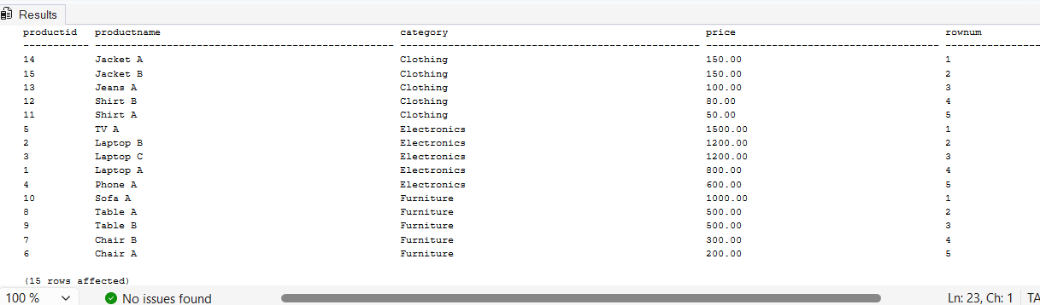
from products;
select
productid,
productname,
category,
price,
rank() over
(
partition by category
order by price desc
)
as rankvalue
from products;
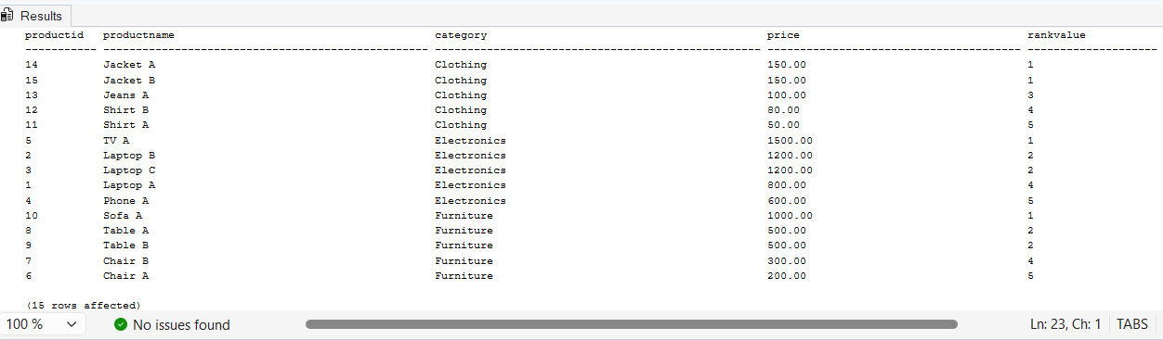
select
productid,
productname,
category,
price,
dense_rank() over
(
partition by category
order by price desc
)
as denserankvalue
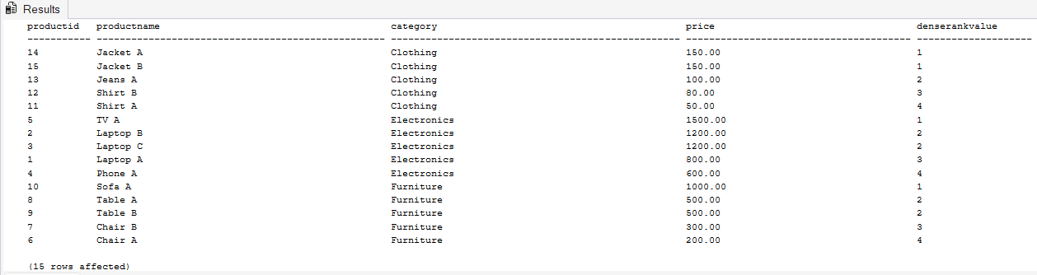
from products;
with productranks as
(
select
productid,
productname,
category,
price,
row_number() over
(
partition by category
order by price desc
)
as rownum
from products
)
select *
from productranks where rownum<=3;
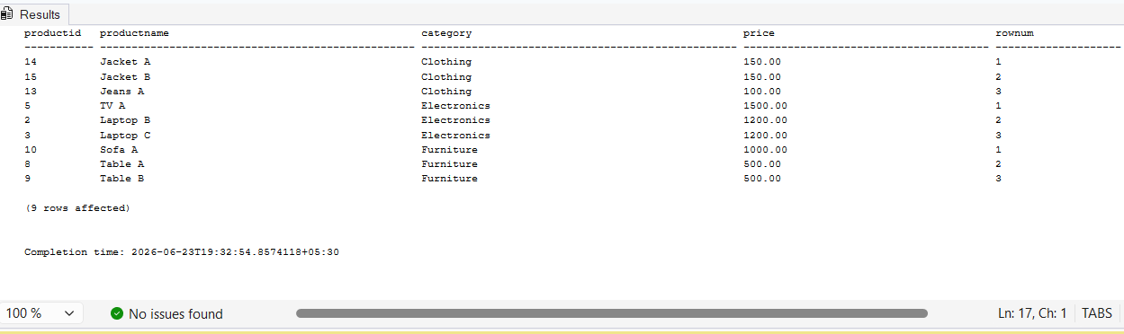

with productranks as
(
select
productid,
productname,
category,
price,
rank() over
(
partition by category
order by price desc
)
as rankvalue
from products
)
select *
from productranks where rankvalue<=3;


with productranks as
(
select
productid,
productname,
category,
price,
dense_rank() over
(
partition by category
order by price desc
)
as denserankvalue
from products
)
select *
from productranks where denserankvalue<=3;
